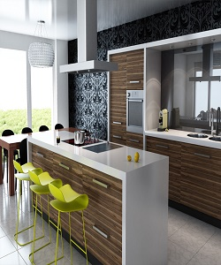

Modern Kitchen Cabinet

$254.90

Availability: In stock

Description

Modern kitchen design with brown cabinet’s ND drawers. Glossy white tabletop cabinets. Matte wood brown door, soft close hinges, drawer boxes and lifting mechanisms. Full assembly instructions are included in the box, certified for the highest quality.